- Tên và phân loại:

- Mục đích, ý nghĩa:
Without violating encapsulation, capture and externalize an object's
internal state so that the object can be restored to this state later
- Động lực sử dụng:
- Many technical processes involve the exploration of some complex
data structure. Often we need to backtrack when a particular path
proves unproductive
• Examples: graph algorithms, searching knowledge bases, and text
navigation
- A graphical editor may encapsulate the connectivity relationships
between objects in a class, whose public interface might be insufficient to allow precise reversal of a move operation
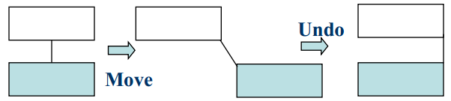
- Khi nào sử dụng:
- A snapshot of an object's state must be saved so that it can
be restored to that state later, and
- A direct interface to obtaining the state would expose
implementation details and break the object's encapsulation
- Cấu trúc
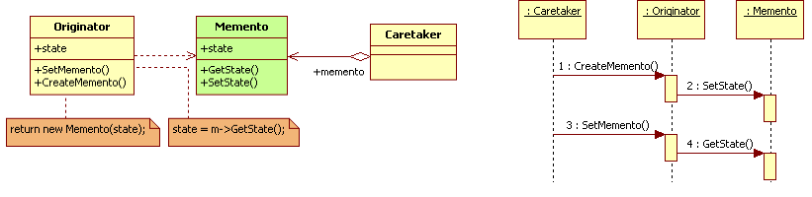
- Các thành viên - Sự cộng tác
- Originator
• Creates a memento containing a snapshot of its current internal
state
• Uses the memento to restore its internal state
- Caretaker
• Responsible for the memento's safekeeping
• Never operates on or examines the contents of a memento
- Memento
• Stores internal state of the Originator object. The memento may
store as much or as little of the originator's internal state as
necessary at its originator's discretion
• Protects against access by objects other than the originator
• Mementos have effectively two interfaces
➢ - Caretaker sees a narrow interface to the Memento – it can only pass
the memento to other objects
➢ - Originator, in contrast, sees a wide interface, one that lets it access all
the data necessary to restore itself to its previous state. Ideally, only
the originator that produced the memento would be permitted to
access the memento's internal state
- Các hệ quả mang lại:
- Preserving encapsulation boundaries
• Memento avoids exposing information that only an originator
should manage but that must be stored nevertheless outside the
originator. The pattern shields other objects from potentially
complex Originator internals, thereby preserving encapsulation
boundaries
- Simplifies Originator
• In other encapsulation-preserving designs, Originator keeps the
versions of internal state that clients have requested. That puts all
the storage management burden on Originator. Having clients
manage the state they ask for simplifies Originator and keeps
- Using mementos might be expensive
• Might incur considerable overhead if Originator must copy large
amounts of information to store in the memento or if clients
create and return mementos to the originator often enough.
Unless encapsulating and restoring Originator state is cheap, the
pattern might not be appropriate
- Defining narrow and wide interfaces
• May be difficult in some languages to ensure that only the
originator can access the memento's state
- Hidden costs in caring for mementos
• A caretaker is responsible for deleting the mementos it cares for.
However, the caretaker has no idea how much state is in the
memento. Hence an otherwise lightweight caretaker might incur
large storage costs when it stores mementos
- Chú ý liên quan đến cài đặt:

- Hệ thống thực tế

- Mẫu liên quan
- Command: Commands can use mementos to maintain state
for undoable operations
- Iterator: Mementos can be used for iteration as described
earlier

